**Practical 1: Show steps to create a Simple Project in Android Studio & write a simple “Hello World” Program.**

**Step 1:** Create New Project in Android Studio

Open Android Studio and go to the *File Menu >> New >> New Project*.

**Step 2:** Configure Your New Project

Add your application details over here and hit "Next" button.

i.e.

* Application name
* Company domain
* Package name
* Project location

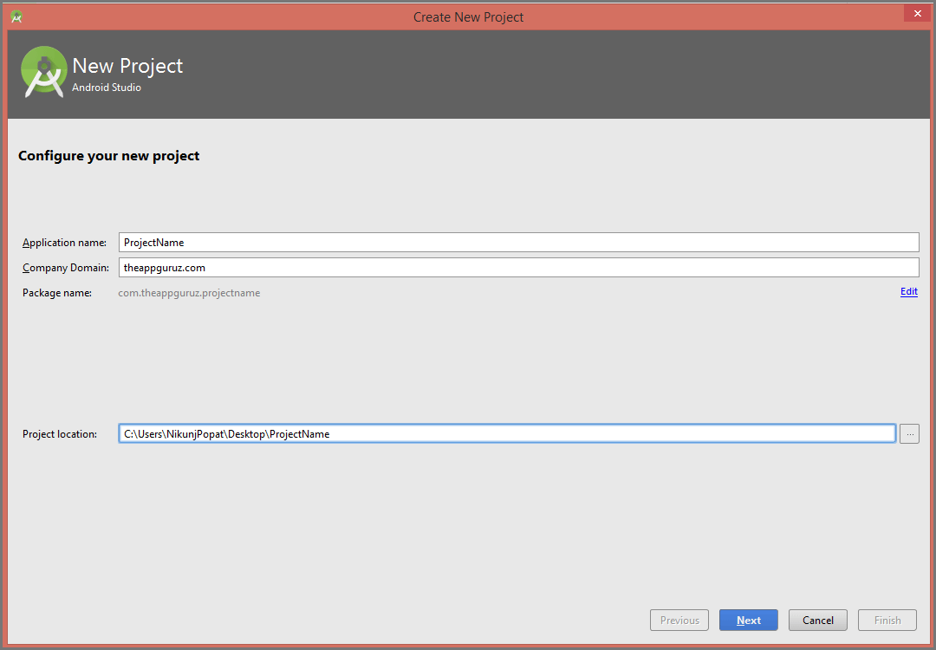

**Step 3:** Target Android Devices

Select the form factors your app will be run on. Here, you can select device type for your android application. And at the same time, you select Minimum SDK which will be supported by your android application.

When you select Minimum SDK, Android studio will give you some active android devices percentage that will support your android application. Otherwise, you can also click on "Help me choose" button for more information about android platform versions.

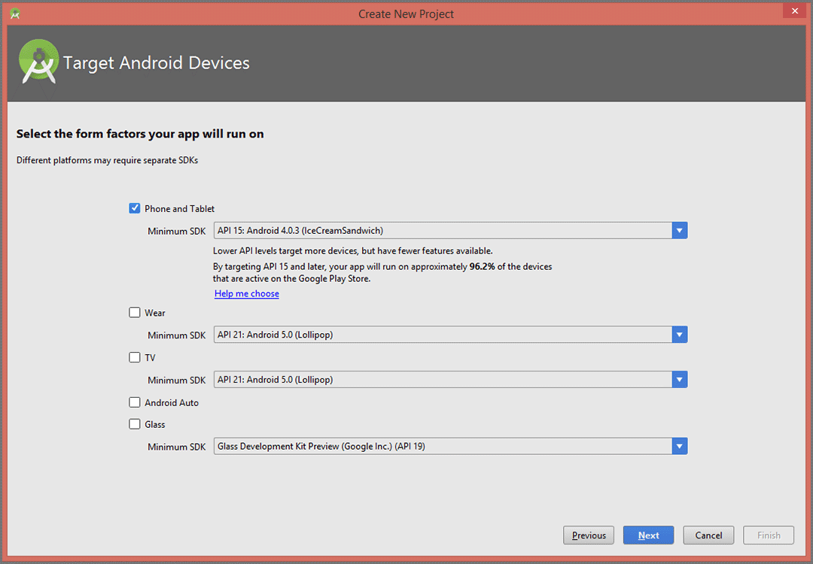

Hit "Next" button once you are done.

**Step 4:** Add activity

This screen suggests you add any activity at first. If you don’t want to add any activity at starting, you can select Add no activity option. If you have selected Phone and Tablet in option in the last screen then it will display the only phone related suggestions. Select Activity as per your project requirements.

For example, select Google Maps Activity for google map project, Blank Activity for blank project etc.

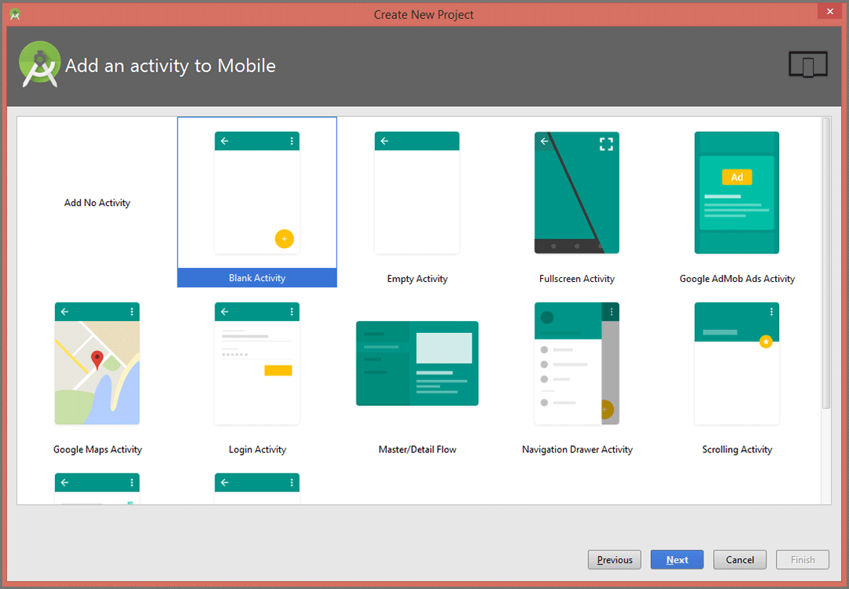

If you are done with it, click "Next" button.

**Step 5:** Customize the Activity

Here, you can customize your selected activity. You can change your Activity name from here. And also you can change Layout name (that will be attached to your activity), Title (Title of the activity), Menu Resource Name (Menu’s resource file name).

If you want to add fragment to your activity then select Use a fragment option given below.

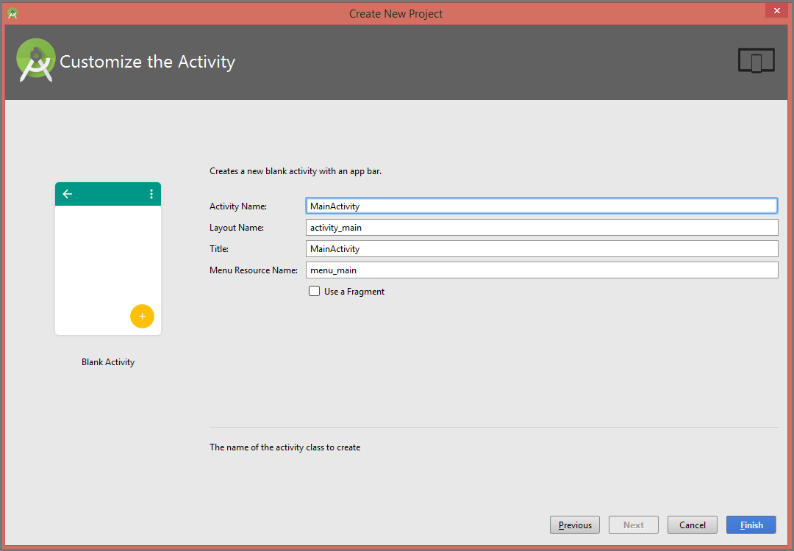

**Input**

**Main Activity.java**

package com.example.hello.helloworld;

import android.support.v7.app.AppCompatActivity;

import android.os.Bundle;

public class MainActivity extends AppCompatActivity {

@Override

protected void onCreate(Bundle savedInstanceState) {

super.onCreate(savedInstanceState);

setContentView(R.layout.activity_main);

}

}

**activity_main.xml**

<?xml version="1.0" encoding="utf-8"?>

<android.support.constraint.ConstraintLayout xmlns:android="http://schemas.android.com/apk/res/android"

xmlns:app="http://schemas.android.com/apk/res-auto"

xmlns:tools="http://schemas.android.com/tools"

android:layout_width="match_parent"

android:layout_height="match_parent"

android:background="#00FFFF"

tools:context=".MainActivity">

<TextView

android:id="@+id/H1"

style="@android:style/Widget.Holo.TextView.SpinnerItem"

android:layout_width="wrap_content"

android:layout_height="wrap_content"

android:text="Hello World!"

android:textColor="#000000"

android:textSize="30sp"

app:fontFamily="casual"

app:layout_constraintBottom_toBottomOf="parent"

app:layout_constraintLeft_toLeftOf="parent"

app:layout_constraintRight_toRightOf="parent"

app:layout_constraintTop_toTopOf="parent" />

</android.support.constraint.ConstraintLayout>

**Output:**

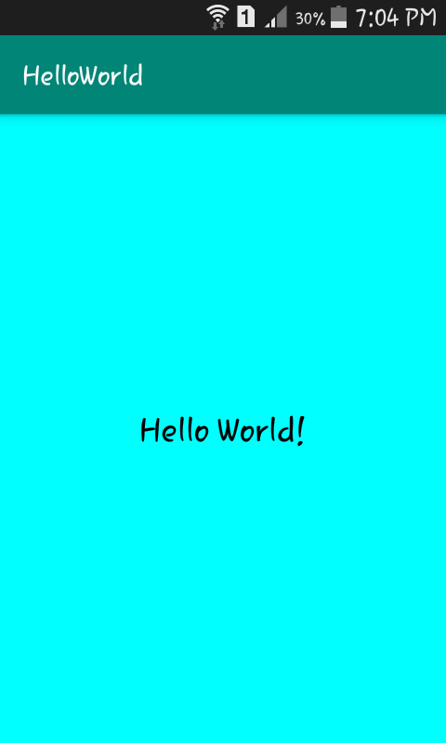

**Practical 2: Android Resources: (Color, Theme, String, Drawable, Dimension, Image)**

**Color:**

**Color.xml:**

*<?***xml version="1.0" encoding="utf-8"***?>*

<**resources**>

<**color name="colorPrimary"**>#008577</**color**>

<**color name="colorPrimaryDark"**>#00574B</**color**>

<**color name="colorAccent"**>#D81B60</**color**>

<**color name="colorRed"**>#FF0000</**color**>

<**color name="colorBlue"**>#0000FF</**color**></**resources**>

**activity_main_xml:**

*<?***xml version="1.0" encoding="utf-8"***?>*

<**LinearLayout xmlns:android="http://schemas.android.com/apk/res/android"**

**xmlns:app="http://schemas.android.com/apk/res-auto"**

**xmlns:tools="http://schemas.android.com/tools"**

**android:layout_width="match_parent"**

**android:layout_height="match_parent"**

**android:orientation="vertical"**

**tools:context=".MainActivity"**>

<**TextView**

**android:id="@+id/textview1"**

**android:layout_width="wrap_content"**

**android:layout_height="wrap_content"**

**android:background="@color/colorRed"**

**android:textColor="@color/colorPrimaryDark"**

**android:textSize="@android:dimen/app_icon_size"**

**android:text="Shaliendra Education Society's"**/>

</**LinearLayout**>

**OUTPUT:**

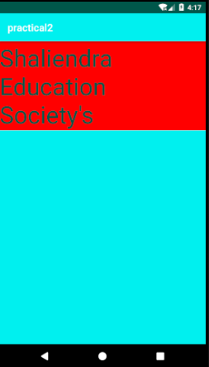

**Styles:**

**styles.xml:**

<**resources**>

<**style name="BlueTheme" parent="Theme.AppCompat.Light.DarkActionBar"**>

<**item name="colorPrimary"**>@color/colorPrimary</**item**>

<**item name="colorPrimaryDark"**>@color/colorPrimaryDark</**item**>

<**item name="colorAccent"**>@color/colorAccent</**item**>

<**item name="android:background"**>#00F0EF</**item**>

<**item name="android:textColor"**>#000000</**item**>

</**style**></**resources**>

**AndroidManifest.xml:**

*<?***xml version="1.0" encoding="utf-8"***?>*

<**manifest xmlns:android="http://schemas.android.com/apk/res/android"**

**package="com.example.myapplication"**>  
 <**application**

**android:allowBackup="true"**

**android:icon="@mipmap/ic_launcher"**

**android:label="@string/app_name"**

**android:roundIcon="@mipmap/ic_launcher_round"**

**android:supportsRtl="true"  
 android:theme="@style/BlueTheme"**>

<**activity android:name=".MainActivity"**>

<**intent-filter**>

<**action android:name="android.intent.action.MAIN"** />

<**category android:name="android.intent.category.LAUNCHER"** />

</**intent-filter**></**activity**></**application**></**manifest**>

**OUTPUT:**

**Before After**

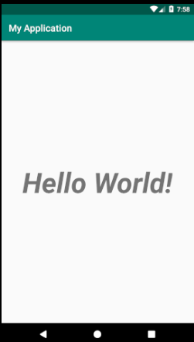 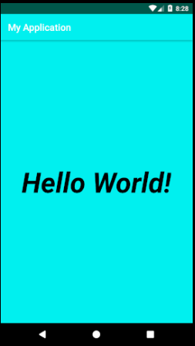

**String:**

**string.xml:**

<**resources**>

<**string name="app_name"**>Android Studio</**string**>

<**string name="college"**>Shailendra Degree College</**string**></**resources**>

**activity_main.xml:**

*<?***xml version="1.0" encoding="utf-8"***?>*

<**android.support.constraint.ConstraintLayout xmlns:android="http://schemas.android.com/apk/res/android"**

**xmlns:app="http://schemas.android.com/apk/res-auto"**

**xmlns:tools="http://schemas.android.com/tools"**

**android:layout_width="match_parent"**

**android:layout_height="match_parent"**

**android:orientation="vertical"**

**tools:context=".MainActivity"**>

<**TextView**

**android:layout_width="wrap_content"**

**android:layout_height="wrap_content"**

**android:text="@string/app_name"**

**android:textSize="50sp"**

**android:textStyle="bold|italic"**

**app:layout_constraintBottom_toBottomOf="parent"**

**app:layout_constraintHorizontal_bias="0.494"**

**app:layout_constraintLeft_toLeftOf="parent"**

**app:layout_constraintRight_toRightOf="parent"**

**app:layout_constraintTop_toTopOf="parent"**

**app:layout_constraintVertical_bias="0.218"** />

<**TextView**

**android:layout_width="wrap_content"**

**android:layout_height="wrap_content"**

**android:text="@string/college"**

**android:textSize="35sp"**

**android:textStyle="bold|italic"**

**tools:layout_editor_absoluteX="0dp"**

**tools:layout_editor_absoluteY="55dp"** />

</**android.support.constraint.ConstraintLayout**>

**OUTPUT:**

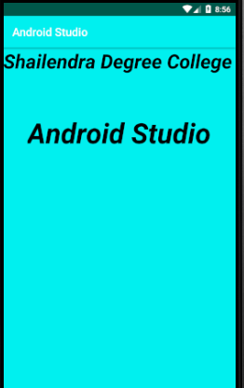

**Drawables and Images :**

**activity_main_xml:**

*<?***xml version="1.0" encoding="utf-8"***?>*<**LinearLayout xmlns:android="http://schemas.android.com/apk/res/android"  
 xmlns:app="http://schemas.android.com/apk/res-auto"  
 xmlns:tools="http://schemas.android.com/tools"  
 android:layout_width="match_parent"  
 android:layout_height="match_parent"  
 android:orientation="vertical"  
 tools:context=".MainActivity"**>  
  
 <**ImageView  
 android:id="@+id/img1"  
 android:layout_width="wrap_content"  
 android:layout_height="wrap_content"  
 android:src="@drawable/star"** />  
</**LinearLayout**>

**OUTPUT:**

**Add Images:**

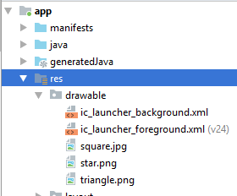 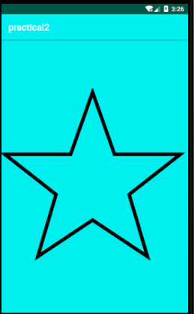

**Dimension:**

**dimens.xml:**

*<?***xml version="1.0" encoding="utf-8"***?>*

<**resources**>

<**dimen name="textview_height"**>35dp</**dimen**>

<**dimen name="textview_width"**>150dp</**dimen**>

<**dimen name="font_size"**>26sp</**dimen**></**resources**>

**activity_main_xml:**

*<?***xml version="1.0" encoding="utf-8"***?>*

<**LinearLayout xmlns:android="http://schemas.android.com/apk/res/android"**

**xmlns:app="http://schemas.android.com/apk/res-auto"**

**xmlns:tools="http://schemas.android.com/tools"**

**android:layout_width="match_parent"  
 android:layout_height="match_parent"**

**android:orientation="vertical"**

**tools:context=".MainActivity"**>

<**TextView**

**android:layout_width="wrap_content"**

**android:layout_height="wrap_content"  
 android:text="@string/College"**/>  
 <**TextView  
 android:layout_width="wrap_content"  
 android:layout_height="wrap_content"  
 android:textSize="@dimen/font_size"  
 android:text="Shaliendra Education Society's"**/>

</**LinearLayout**>

**OUTPUT:**

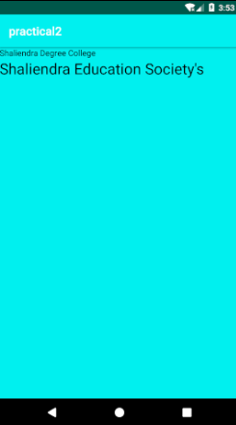

**Practical 3(A): Activity Lifecycle**

**Input**

**MainActivity.java**

package com.example.hello.androidlifecycle;

import android.support.v7.app.AppCompatActivity;

import android.os.Bundle;

import android.util.Log;

public class MainActivity extends AppCompatActivity {

String tag="Lifecycle";

@Override

protected void onCreate(Bundle savedInstanceState) {

super.onCreate(savedInstanceState);

setContentView(R.layout.activity_main);

Log.d(tag,"In the onCreate() event");

}

public void onStart(){

super.onStart();

Log.d(tag,"In the onStart() event");

}

public void onRestart() {

super.onRestart();

Log.d(tag, "In the onRestart() event");

}

public void onResume(){

super.onResume();

Log.d(tag,"In the onResume() event");

}

public void onPause(){

super.onPause();

Log.d(tag,"In the onPause() event");

}

public void onStop(){

super.onStop();

Log.d(tag,"In the onStop() event");

}

public void onDestroy(){

super.onDestroy();

Log.d(tag,"In the onDestroy() event");

}

}

**Output:**

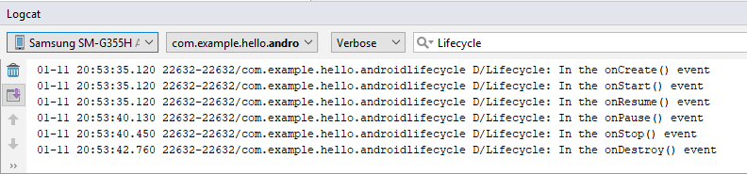

**Practical 3(B): Fragment Lifecycle**

**Input:**

**BlankFragment.java**

package com.example.hello.newfragments;

import android.content.Context;

import android.net.Uri;

import android.os.Bundle;

import android.support.annotation.NonNull;

import android.support.annotation.Nullable;

import android.support.v4.app.Fragment;

import android.view.LayoutInflater;

import android.view.View;

import android.util.Log;

import android.view.ViewGroup;

public class BlankFragment extends Fragment {

String tag="Lifecycle";

public BlankFragment(){

//Blank Constructor Required*

}

@Override

public View onCreateView(LayoutInflater inflater, ViewGroup container,

Bundle savedInstanceState) {

return inflater.inflate(R.layout.fragment_blank, container, false);

}

@Override

public void onCreate(Bundle savedInstanceState) {

super.onCreate(savedInstanceState);

}

@Override

public void onViewCreated(@NonNull View view, @Nullable Bundle savedInstanceState) {

super.onViewCreated(view, savedInstanceState);

Log.d(tag,"OnViewCreated() method");

}

@Override

public void onActivityCreated(@Nullable Bundle savedInstanceState) {

super.onActivityCreated(savedInstanceState);

Log.d(tag,"OnActivityCreated() method");

}

@Override

public void onStart() {

super.onStart();

Log.d(tag,"OnStart() method");

}

@Override

public void onResume() {

super.onResume();

Log.d(tag,"OnResume() method");

}

@Override

public void onPause() {

super.onPause();

Log.d(tag,"OnPause() method");

}

@Override

public void onStop() {

super.onStop();

Log.d(tag,"OnStop() method");

}

@Override

public void onDestroyView() {

super.onDestroyView();

Log.d(tag,"OnDestroyView() method");

}

@Override

public void onDestroy() {

super.onDestroy();

Log.d(tag,"OnDestroy() method");

}

@Override

public void onAttach(Context context) {

super.onAttach(context);

Log.d(tag,"OnAttach() method");

}

}

**activity_main.xml**

<?xml version="1.0" encoding="utf-8"?>

<android.support.constraint.ConstraintLayout xmlns:android="http://schemas.android.com/apk/res/android"

xmlns:app="http://schemas.android.com/apk/res-auto"

xmlns:tools="http://schemas.android.com/tools"

android:layout_width="match_parent"

android:layout_height="match_parent"

tools:context=".MainActivity">

<fragment

android:id="@+id/test_fragment"

class="com.example.hello.newfragments.BlankFragment"

tools:layout="@layout/fragment_blank"

android:layout_width="match_parent"

android:layout_height="match_parent"/>

</android.support.constraint.ConstraintLayout>

**Output:**

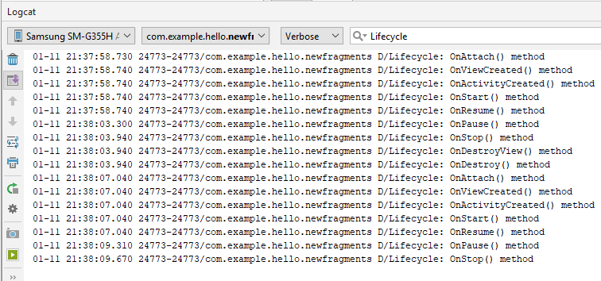

**Practical 4: Program for Testing Different Layouts.**

**Create this Activity**

* **AbsoluteLayout.java**
* **FrameLayout.java**
* **GridviewLayout.java**
* **LinearLayoutHorizontal.java**
* **LinearLayoutVertical.java**
* **ListviewLayout.java**
* **RelativeLayout.java**
* **ScrollLayout.java**
* **TableActivity.java**

**Main Activity.java**

**package** com.example.pc.testinglayouts;  
**import** android.content.Intent;  
**import** android.support.v7.app.AppCompatActivity;  
**import** android.os.Bundle;  
**import** android.app.Activity;  
**import** android.view.View;  
**import** android.widget.*;  
**public class** MainActivity **extends** AppCompatActivity {  
 @Override  
 **protected void** onCreate(Bundle savedInstanceState) {  
 **super**.onCreate(savedInstanceState);  
 setContentView(R.layout.activity_main);  
 Button brel= (Button) findViewById(R.id.rel);  
 Button bllh= (Button) findViewById(R.id.llh);  
 Button bllv= (Button) findViewById(R.id.llv);  
 Button bTab= (Button) findViewById(R.id.tl);  
 Button bsv= (Button) findViewById(R.id.sl);  
 Button bab= (Button) findViewById(R.id.al);  
 Button bList= (Button) findViewById(R.id.lv);  
 Button bgv= (Button) findViewById(R.id.gv);  
 Button bfv= (Button) findViewById(R.id.fl);  
 brel.setOnClickListener(**new** View.OnClickListener() {  
 @Override  
 **public void** onClick(View v) {  
 Intent i=**new** Intent(getApplicationContext(),RelativeLayout.**class**);  
 startActivity(i);  
 }  
 });  
 bllh.setOnClickListener(**new** View.OnClickListener() {  
 @Override  
 **public void** onClick(View v) {  
 Intent i=**new** Intent(getApplicationContext(),LinearLayoutHorizontal.**class**);  
 startActivity(i);  
 }  
 });  
 bllv.setOnClickListener(**new** View.OnClickListener() {  
 @Override  
 **public void** onClick(View v) {  
 Intent i=**new** Intent(getApplicationContext(),LinearLayoutVertical.**class**);  
 startActivity(i);  
 }  
 });  
 bTab.setOnClickListener(**new** View.OnClickListener() {  
 @Override  
 **public void** onClick(View v) {  
 Intent i=**new** Intent(getApplicationContext(),TableActivity.**class**);  
 startActivity(i);  
 }  
 });  
 bsv.setOnClickListener(**new** View.OnClickListener() {  
 @Override  
 **public void** onClick(View v) {  
 Intent i=**new** Intent(getApplicationContext(),ScrollLayout.**class**);  
 startActivity(i);  
 }  
 });  
 bab.setOnClickListener(**new** View.OnClickListener() {  
 @Override  
 **public void** onClick(View v) {  
 Intent i=**new** Intent(getApplicationContext(),AbsoluteLayout.**class**);  
 startActivity(i);  
 }  
 });  
 bList.setOnClickListener(**new** View.OnClickListener() {  
 @Override  
 **public void** onClick(View v) {  
 Intent i=**new** Intent(getApplicationContext(),ListviewLayout.**class**);  
 startActivity(i);  
 }  
 });  
 bgv.setOnClickListener(**new** View.OnClickListener() {  
 @Override  
 **public void** onClick(View v) {  
 Intent i=**new** Intent(getApplicationContext(),GridviewLayout.**class**);  
 startActivity(i);  
 }  
 });  
 bfv.setOnClickListener(**new** View.OnClickListener() {  
 @Override  
 **public void** onClick(View v) {  
 Intent i=**new** Intent(getApplicationContext(),FrameLayout.**class**);  
 startActivity(i);  
 }  
 });  
 }  
}

**activity_main.xml**

*<?***xml version="1.0" encoding="utf-8"***?>*<**LinearLayout  
 xmlns:android="http://schemas.android.com/apk/res/android"  
 xmlns:tools="http://schemas.android.com/tools"  
 xmlns:app="http://schemas.android.com/apk/res-auto"  
 android:layout_width="match_parent"  
 android:layout_height="match_parent"  
 android:orientation="vertical"  
 tools:context="com.example.pc.testinglayouts.MainActivity"**>  
  
 <**TextView  
 android:layout_width="match_parent"  
 android:layout_height="wrap_content"  
 android:layout_gravity="center"  
 android:text="Layout Demonstration"  
 android:textAlignment="center"  
 android:textSize="30sp"  
 android:textStyle="bold"** />  
  
 <**Button  
 android:layout_width="match_parent"  
 android:layout_height="wrap_content"  
 android:text="Relative Layout"  
 android:layout_gravity="center"  
 android:id="@+id/rel"**/>  
 <**Button  
 android:layout_width="match_parent"  
 android:layout_height="wrap_content"  
 android:text="Linear Layout(Horizontal)"  
 android:layout_gravity="center"  
 android:id="@+id/llh"**/>  
 <**Button  
 android:layout_width="match_parent"  
 android:layout_height="wrap_content"  
 android:text="Linear Layout(Vertical)"  
 android:layout_gravity="center"  
 android:id="@+id/llv"**/>  
 <**Button  
 android:layout_width="match_parent"  
 android:layout_height="wrap_content"  
 android:text="Table Layout"  
 android:layout_gravity="center"  
 android:id="@+id/tl"**/>  
 <**Button  
 android:layout_width="match_parent"  
 android:layout_height="wrap_content"  
 android:text="Scrollview Layout"  
 android:layout_gravity="center"  
 android:id="@+id/sl"**/>  
 <**Button  
 android:layout_width="match_parent"  
 android:layout_height="wrap_content"  
 android:text="Absolute Layout"  
 android:layout_gravity="center"  
 android:id="@+id/al"**/>  
 <**Button  
 android:layout_width="match_parent"  
 android:layout_height="wrap_content"  
 android:text="List View"  
 android:layout_gravity="center"  
 android:id="@+id/lv"**/>  
 <**Button  
 android:layout_width="match_parent"  
 android:layout_height="wrap_content"  
 android:text="Grid View"  
 android:layout_gravity="center"  
 android:id="@+id/gv"**/>  
 <**Button  
 android:layout_width="match_parent"  
 android:layout_height="wrap_content"  
 android:text="Frame Layout"  
 android:layout_gravity="center"  
 android:id="@+id/fl"**/>  
</**LinearLayout**>

**AbsolueLayout.java**

**\*\*\*No Change\*\*\***

**activity_absolute_layout.xml**

*<?***xml version="1.0" encoding="utf-8"***?>*<**AbsoluteLayout xmlns:android="http://schemas.android.com/apk/res/android"  
 xmlns:app="http://schemas.android.com/apk/res-auto"  
 xmlns:tools="http://schemas.android.com/tools"  
 android:layout_width="match_parent"  
 android:layout_height="match_parent"  
 tools:context="com.example.pc.testinglayouts.AbsoluteLayout"**>  
  
 <**Button  
 android:id="@+id/button11"  
 android:layout_width="wrap_content"  
 android:layout_height="wrap_content"  
 android:layout_x="22dp"  
 android:layout_y="16dp"  
 android:text="Button"** />  
  
 <**Button  
 android:id="@+id/button12"  
 android:layout_width="wrap_content"  
 android:layout_height="wrap_content"  
 android:layout_x="132dp"  
 android:layout_y="128dp"  
 android:text="Button"** />  
  
 <**Button  
 android:id="@+id/button14"  
 android:layout_width="wrap_content"  
 android:layout_height="wrap_content"  
 android:layout_x="207dp"  
 android:layout_y="16dp"  
 android:text="Button"** />  
  
 <**Button  
 android:id="@+id/button13"  
 android:layout_width="wrap_content"  
 android:layout_height="wrap_content"  
 android:layout_x="30dp"  
 android:layout_y="205dp"  
 android:text="Button"** />  
</**AbsoluteLayout**>

**FrameLayout.java**

**\*\*\*No Change\*\*\***

**activity_frame_layout.xml**

*<?***xml version="1.0" encoding="utf-8"***?>*<**RelativeLayout xmlns:android="http://schemas.android.com/apk/res/android"  
 xmlns:app="http://schemas.android.com/apk/res-auto"  
 xmlns:tools="http://schemas.android.com/tools"  
 android:layout_width="match_parent"  
 android:layout_height="match_parent"  
 tools:context="com.example.pc.testinglayouts.FrameLayout"**>  
  
 <**TextView  
 android:id="@+id/Tvcom"  
 android:layout_width="wrap_content"  
 android:layout_height="wrap_content"  
 android:text="Hello Android!!"  
 android:layout_alignParentTop="true"  
 android:layout_alignParentLeft="true"** />  
  
 <**FrameLayout  
 android:layout_width="wrap_content"  
 android:layout_height="wrap_content"  
 android:layout_alignLeft="@id/Tvcom"  
 android:layout_below="@id/Tvcom"  
 android:layout_centerHorizontal="true"**>  
 <**ImageView  
 android:src="@mipmap/ic_launcher"  
 android:layout_width="wrap_content"  
 android:layout_height="wrap_content"** />  
 </**FrameLayout**>  
</**RelativeLayout**>

**GridviewLayout.java**

**package** com.example.pc.testinglayouts;  
**import** android.content.Context;  
**import** android.support.v7.app.AppCompatActivity;  
**import** android.os.Bundle;  
**import** android.app.Activity;  
**import** android.view.*;  
**import** android.widget.*;  
**import** android.widget.AdapterView;  
**import** android.widget.BaseAdapter;  
**import** android.widget.ImageView;  
**public class** GridviewLayout **extends** AppCompatActivity {  
 Integer[] imgids={  
 R.mipmap.ic_launcher,  
 R.mipmap.ic_launcher,  
 R.mipmap.ic_launcher,  
 R.mipmap.ic_launcher,  
 R.mipmap.ic_launcher,  
 R.mipmap.ic_launcher,  
 R.mipmap.ic_launcher,  
 };  
 @Override  
 **protected void** onCreate(Bundle savedInstanceState) {  
 **super**.onCreate(savedInstanceState);  
 setContentView(R.layout.activity_gridview_layout);  
 GridView gridView= (GridView) findViewById(R.id.gdview);  
 gridView.setAdapter(**new** ImageAdapter(**this**));  
 gridView.setOnItemClickListener(**new** AdapterView.OnItemClickListener(){  
 **public void** onItemClick(AdapterView parent, View v,**int** pos,**long** id){  
 Toast.makeText(getBaseContext(),**"pic"**+(pos+1)+**"selected"**,  
 Toast.LENGTH_SHORT).show();  
 }  
 });  
 }  
 **public class** ImageAdapter **extends** BaseAdapter{  
 **private** Context context;  
 **public** ImageAdapter(Context c){  
 context=c;

}  
 **public int** getCount(){  
 **return** imgids.length;

}  
 **public** Object getItem(**int** pos){  
 **return** pos;

}  
 **public long** getItemId(**int** pos){  
 **return** pos;  
 }  
 @Override  
 **public** View getView(**int** pos, View convertView, ViewGroup parent) {  
 ImageView imageView;  
 **if**(convertView==**null**){  
 imageView=**new** ImageView(context);  
 imageView.setLayoutParams(**new** GridView.LayoutParams(85,85));  
 imageView.setScaleType(ImageView.ScaleType.CENTER_CROP);  
 imageView.setPadding(5,5,5,5);  
 }**else**{  
 imageView= (ImageView) convertView;  
 }  
 imageView.setImageResource(imgids[pos]);  
 **return** imageView;  
 }

}  
}

**activity_gridview_layout.xml**

*<?***xml version="1.0" encoding="utf-8"***?>*<**LinearLayout xmlns:android="http://schemas.android.com/apk/res/android"  
 xmlns:app="http://schemas.android.com/apk/res-auto"  
 xmlns:tools="http://schemas.android.com/tools"  
 android:layout_width="match_parent"  
 android:layout_height="match_parent"  
 android:orientation="vertical"  
 tools:context="com.example.pc.testinglayouts.GridviewLayout"**>  
 <**TextView  
 android:layout_width="match_parent"  
 android:layout_height="wrap_content"  
 android:text="Grid View"  
 android:gravity="center"**/>  
 <**GridView  
 android:id="@+id/gdview"  
 android:layout_width="fill_parent"  
 android:layout_height="fill_parent"  
 android:numColumns="auto_fit"  
 android:verticalSpacing="10dp"  
 android:horizontalSpacing="10dp"  
 android:columnWidth="90dp"  
 android:stretchMode="columnWidth"  
 android:gravity="center"**></**GridView**>  
</**LinearLayout**>

**LinearLayoutHorizontal.java**

**\*\*\*No Change\*\*\***

**activity_linear_layout_horizontal.xml**

*<?***xml version="1.0" encoding="utf-8"***?>*<**LinearLayout xmlns:android="http://schemas.android.com/apk/res/android"  
 xmlns:app="http://schemas.android.com/apk/res-auto"  
 xmlns:tools="http://schemas.android.com/tools"  
 android:layout_width="match_parent"  
 android:layout_height="match_parent"  
 tools:context="com.example.pc.testinglayouts.LinearLayoutHorizontal"**>  
  
  
 <**Button  
 android:id="@+id/button4"  
 android:layout_width="wrap_content"  
 android:layout_height="wrap_content"  
 android:layout_weight="1"  
 android:text="Button"** />  
  
 <**Button  
 android:id="@+id/button6"  
 android:layout_width="wrap_content"  
 android:layout_height="wrap_content"  
 android:layout_weight="1"  
 android:text="Button"** />  
  
 <**Button  
 android:id="@+id/button5"  
 android:layout_width="wrap_content"  
 android:layout_height="wrap_content"  
 android:layout_weight="1"  
 android:text="Button"** />  
  
 <**Button  
 android:id="@+id/button3"  
 android:layout_width="wrap_content"  
 android:layout_height="wrap_content"  
 android:layout_weight="1"  
 android:text="Button"** />  
</**LinearLayout**>

**LinearLayoutVertical.java**

**\*\*\*No Change\*\*\***

**activity_linear_layout_vertical.xml**

*<?***xml version="1.0" encoding="utf-8"***?>*<**LinearLayout xmlns:android="http://schemas.android.com/apk/res/android"  
 xmlns:app="http://schemas.android.com/apk/res-auto"  
 xmlns:tools="http://schemas.android.com/tools"  
 android:layout_width="match_parent"  
 android:layout_height="match_parent"  
 android:orientation="vertical"  
 tools:context="com.example.pc.testinglayouts.LinearLayoutVertical"**>  
 <**Button  
 android:id="@+id/button8"  
 android:layout_width="wrap_content"  
 android:layout_height="wrap_content"  
 android:layout_weight="1"  
 android:text="Button"** />  
  
 <**Button  
 android:id="@+id/button10"  
 android:layout_width="wrap_content"  
 android:layout_height="wrap_content"  
 android:layout_weight="1"  
 android:text="Button"** />  
 <**Button  
 android:id="@+id/button9"  
 android:layout_width="wrap_content"  
 android:layout_height="wrap_content"  
 android:layout_weight="1"  
 android:text="Button"** />  
 <**Button  
 android:id="@+id/button7"  
 android:layout_width="wrap_content"  
 android:layout_height="wrap_content"  
 android:layout_weight="1"  
 android:text="Button"** />  
</**LinearLayout**>

**ListviewLayout.java**

**package** com.example.pc.testinglayouts;  
  
**import** android.support.v7.app.AppCompatActivity;  
**import** android.os.Bundle;  
**import** android.app.Activity;  
**import** android.view.View;  
**import** android.widget.*;  
  
**public class** ListviewLayout **extends** AppCompatActivity {  
 ListView I;  
 @Override  
 **protected void** onCreate(Bundle savedInstanceState) {  
 **super**.onCreate(savedInstanceState);  
 setContentView(R.layout.activity_listview_layout);  
  
 **final** String[] s={**"Android"**,**"IOS"**,**"Windows"**,**"Linux"**,**"OS"**,**"Symbian"**,**"Blackberry"**,**"J2ME"**};  
 setContentView(R.layout.activity_listview_layout);  
 I= (ListView) findViewById(R.id.lv);  
 ArrayAdapter ada=**new** ArrayAdapter(ListviewLayout.**this**,android.R.layout.simple_list_item_1,s);  
 I.setAdapter(ada);  
 I.setOnItemClickListener(**new** AdapterView.OnItemClickListener() {  
 @Override  
 **public void** onItemClick(AdapterView<?> parent, View view, **int** position, **long** id) {  
 Toast.makeText(ListviewLayout.**this**,**"Item Clicked "**+position,Toast.LENGTH_LONG).show();;  
 Toast.makeText(ListviewLayout.**this**,**"Item: "**+s[position],Toast.LENGTH_SHORT).show();  
 }  
 });  
 }  
}

**activity_listview_layout.xml**

*<?***xml version="1.0" encoding="utf-8"***?>*<**RelativeLayout xmlns:android="http://schemas.android.com/apk/res/android"  
 xmlns:app="http://schemas.android.com/apk/res-auto"  
 xmlns:tools="http://schemas.android.com/tools"  
 android:layout_width="match_parent"  
 android:layout_height="match_parent"  
 tools:context="com.example.pc.testinglayouts.ListviewLayout"**>  
  
  
 <**TextView  
 android:id="@+id/textView8"  
 android:layout_width="wrap_content"  
 android:layout_height="wrap_content"  
 android:layout_centerHorizontal="true"  
 android:layout_alignParentTop="true"  
 android:textSize="30dp"  
 android:text="ListView"** />  
 <**ListView  
 android:id="@+id/lv"  
 android:layout_width="wrap_content"  
 android:layout_height="wrap_content"  
 android:layout_below="@+id/textView8"**>  
 </**ListView**>  
</**RelativeLayout**>

**RelativeLayout.java**

**\*\*\*No Change\*\*\***

**activity_relative_layout.xml**

*<?***xml version="1.0" encoding="utf-8"***?>*<**RelativeLayout xmlns:android="http://schemas.android.com/apk/res/android"  
 xmlns:app="http://schemas.android.com/apk/res-auto"  
 xmlns:tools="http://schemas.android.com/tools"  
 android:layout_width="match_parent"  
 android:layout_height="match_parent"  
 tools:context="com.example.pc.testinglayouts.RelativeLayout"**>  
  
 <**TextView  
 android:id="@+id/textView"  
 android:layout_width="wrap_content"  
 android:layout_height="wrap_content"  
 android:layout_alignParentTop="true"  
 android:layout_centerHorizontal="true"  
 android:layout_marginTop="28dp"  
 android:text="Comments"  
 android:textSize="24sp"** />  
  
 <**EditText  
 android:layout_width="fill_parent"  
 android:layout_height="wrap_content"  
 android:layout_below="@+id/textView"  
 android:layout_alignParentLeft="true"  
 android:layout_alignParentStart="true"  
 android:layout_marginTop="34dp"** />  
  
 <**Button  
 android:id="@+id/button"  
 android:layout_width="wrap_content"  
 android:layout_height="wrap_content"  
 android:layout_below="@+id/textView"  
 android:layout_centerHorizontal="true"  
 android:layout_marginTop="96dp"  
 android:text="Save"** />  
 <**Button  
 android:id="@+id/button2"  
 android:layout_width="wrap_content"  
 android:layout_height="wrap_content"  
 android:layout_alignLeft="@+id/button"  
 android:layout_alignStart="@+id/button"  
 android:layout_below="@+id/button"  
 android:layout_marginTop="52dp"  
 android:text="Cancel"** />  
</**RelativeLayout**>

**ScrollLayout.java**

**\*\*\*No Change\*\*\***

**activity_scroll_layout.xml**

*<?***xml version="1.0" encoding="utf-8"***?>*<**ScrollView xmlns:android="http://schemas.android.com/apk/res/android"  
 xmlns:app="http://schemas.android.com/apk/res-auto"  
 xmlns:tools="http://schemas.android.com/tools"  
 android:layout_width="match_parent"  
 android:layout_height="match_parent"  
 tools:context="com.example.pc.testinglayouts.ScrollLayout"**>  
 <**LinearLayout  
 android:layout_width="wrap_content"  
 android:layout_height="wrap_content"  
 android:orientation="vertical"**>  
 <**TextView  
 android:layout_width="wrap_content"  
 android:layout_height="wrap_content"  
 android:text="Line1"  
 android:textSize="40dp"**/>  
 <**TextView  
 android:layout_width="wrap_content"  
 android:layout_height="wrap_content"  
 android:text="Line2"  
 android:textSize="40dp"**/>  
 <**TextView  
 android:layout_width="wrap_content"  
 android:layout_height="wrap_content"  
 android:text="Line3"  
 android:textSize="40dp"**/>  
 <**TextView  
 android:layout_width="wrap_content"  
 android:layout_height="wrap_content"  
 android:text="Line4"  
 android:textSize="40dp"**/>  
 <**TextView  
 android:layout_width="wrap_content"  
 android:layout_height="wrap_content"  
 android:text="Line5"  
 android:textSize="40dp"**/>  
 <**TextView  
 android:layout_width="wrap_content"  
 android:layout_height="wrap_content"  
 android:text="Line6"  
 android:textSize="40dp"**/>  
 <**TextView  
 android:layout_width="wrap_content"  
 android:layout_height="wrap_content"  
 android:text="Line7"  
 android:textSize="40dp"**/>  
 <**TextView  
 android:layout_width="wrap_content"  
 android:layout_height="wrap_content"  
 android:text="Line8"  
 android:textSize="40dp"**/>  
 <**TextView  
 android:layout_width="wrap_content"  
 android:layout_height="wrap_content"  
 android:text="Line9"  
 android:textSize="40dp"**/>  
 <**TextView  
 android:layout_width="wrap_content"  
 android:layout_height="wrap_content"  
 android:text="Line10"  
 android:textSize="40dp"**/>  
 <**TextView  
 android:layout_width="wrap_content"  
 android:layout_height="wrap_content"  
 android:text="Line11"  
 android:textSize="40dp"**/>  
 <**TextView  
 android:layout_width="wrap_content"  
 android:layout_height="wrap_content"  
 android:text="Line12"  
 android:textSize="40dp"**/>  
 <**TextView  
 android:layout_width="wrap_content"  
 android:layout_height="wrap_content"  
 android:text="Line13"  
 android:textSize="40dp"**/>  
 <**TextView  
 android:layout_width="wrap_content"  
 android:layout_height="wrap_content"  
 android:text="Line14"  
 android:textSize="40dp"**/>  
 <**TextView  
 android:layout_width="wrap_content"  
 android:layout_height="wrap_content"  
 android:text="Line15"  
 android:textSize="40dp"**/>  
  
 </**LinearLayout**>  
  
</**ScrollView**>

**TableActivity.java**

**\*\*\*No Change\*\*\***

**activity_layout.xml**

*<?***xml version="1.0" encoding="utf-8"***?>*<**TableLayout xmlns:android="http://schemas.android.com/apk/res/android"  
 xmlns:app="http://schemas.android.com/apk/res-auto"  
 xmlns:tools="http://schemas.android.com/tools"  
 android:layout_width="match_parent"  
 android:layout_height="match_parent"  
 tools:context="com.example.pc.testinglayouts.TableActivity"**>  
  
 <**TableRow**>  
  
 <**TextView  
 android:id="@+id/textView2"  
 android:layout_width="wrap_content"  
 android:layout_height="wrap_content"  
 android:layout_marginLeft="30dp"  
 android:text="Row1 Column1"** />  
  
 <**TextView  
 android:id="@+id/textView3"  
 android:layout_width="wrap_content"  
 android:layout_height="wrap_content"  
 android:layout_marginLeft="100dp"  
 android:text="Row1 Column2"** />  
 </**TableRow**>  
  
 <**TableRow**>  
  
 <**TextView  
 android:id="@+id/textView4"  
 android:layout_width="wrap_content"  
 android:layout_height="wrap_content"  
 android:layout_marginLeft="30dp"  
 android:text="Row2 Column1"** />  
  
 <**TextView  
 android:id="@+id/textView5"  
 android:layout_width="wrap_content"  
 android:layout_height="wrap_content"  
 android:layout_marginLeft="100dp"  
 android:text="Row2 Column2"** />  
 </**TableRow**>  
  
 <**TableRow**>  
  
 <**TextView  
 android:id="@+id/textView6"  
 android:layout_width="wrap_content"  
 android:layout_height="wrap_content"  
 android:layout_marginLeft="30dp"  
 android:text="Row3 Column1"** />  
  
 <**TextView  
 android:id="@+id/textView7"  
 android:layout_width="wrap_content"  
 android:layout_height="wrap_content"  
 android:layout_marginLeft="100dp"  
 android:text="Row3 Column2"** />  
 </**TableRow**>  
  
 <**TableRow**>  
  
 <**TextView  
 android:id="@+id/text5"  
 android:layout_marginLeft="120dp"  
 android:text="Username"** />  
  
 <**EditText  
 android:id="@+id/txtuname"  
 android:width="200dp"**/>  
  
 </**TableRow**>  
  
 <**TableRow**>  
 <**Button  
 android:id="@+id/button10"  
 android:text="Log In"**/>  
 </**TableRow**>  
  
</**TableLayout**>

**Output**

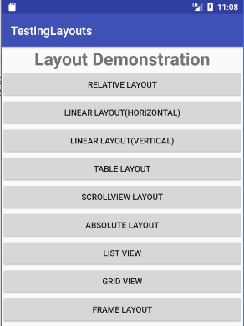 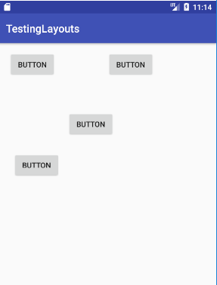

**Absolute Layout**

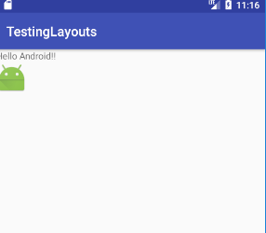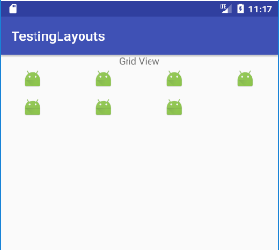

**Grid View Layout**

**Frame Layout**

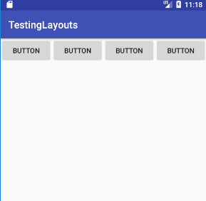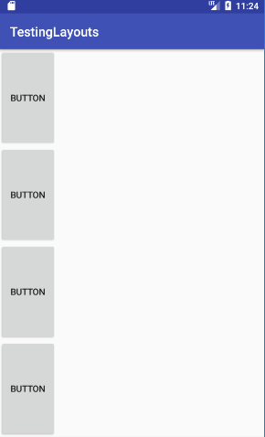

**Linear vertial Layout**

**Linear Horizontal Layout**

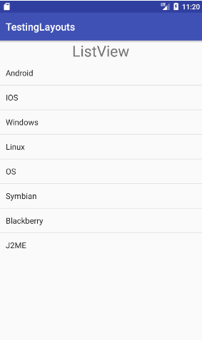 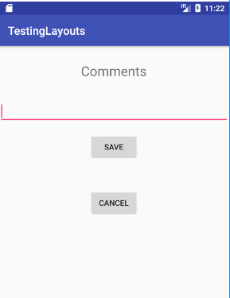

**Relative Layout**

**List View Layout**

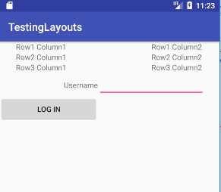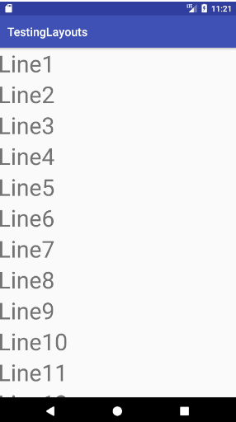

**Table Activiy**

**Scroll Layout**

**Practical 5(A): UI Elements App Bar**

**Input:**

**MainActivity.java**

package com.example.pc.uielements;  
import android.support.v7.app.AppCompatActivity;  
import android.os.Bundle;  
import android.support.v7.widget.Toolbar;  
import android.view.Menu;  
import android.view.MenuInflater;  
import android.view.MenuItem;  
import android.widget.Toast;  
public class MainActivity extends AppCompatActivity {  
 private Toolbar tbar;  
 @Override  
 protected void onCreate(Bundle savedInstanceState) {  
 super.onCreate(savedInstanceState);  
 setContentView(R.layout.*activity_main*);  
 tbar= (Toolbar) findViewById(R.id.*toolbar*);  
 setSupportActionBar(tbar);  
 }  
 @Override  
 public boolean onCreateOptionsMenu(Menu menu) {  
 MenuInflater mi=getMenuInflater();  
 mi.inflate(R.menu.*app_bar_menu*,menu);  
 return true;  
 }  
 @Override  
 public boolean onOptionsItemSelected(MenuItem item) {  
 switch (item.getItemId()){  
 case R.id.*action_search*:  
 Toast.*makeText*(this,"search menu click",Toast.*LENGTH_SHORT*).show();  
 return true;  
 case R.id.*action_about*:  
 Toast.*makeText*(this,"About menu click",Toast.*LENGTH_SHORT*).show();  
 return true;  
 default:  
 return super.onOptionsItemSelected(item);  
 }  
 }  
}

**Styles.xml**

<resources>  
<style name="AppTheme" parent="Theme.AppCompat.Light.NoActionBar">  
 *<!-- Customize your theme here. -->* <item name="colorPrimary">@color/colorPrimary</item>  
 <item name="colorPrimaryDark">@color/colorPrimaryDark</item>  
 <item name="colorAccent">@color/colorAccent</item>  
 </style>  
</resources>

**toolbar_layout.xml**

*<?*xml version="1.0" encoding="utf-8"*?>*<android.support.v7.widget.Toolbar  
 xmlns:android="http://schemas.android.com/apk/res/android"  
 xmlns:app="http://schemas.android.com/apk/res-auto"  
 android:layout_width="match_parent"  
 android:layout_height="?attr/actionBarSize"  
 android:background="@color/colorPrimary"  
 android:theme="@style/ThemeOverlay.AppCompat.Dark.ActionBar"  
 android:id="@+id/toolbar"/ >  
</android.support.v7.widget.Toolbar>

app_bar_menu.xml

*<?*xml version="1.0" encoding="utf-8"*?>*<menu  
 xmlns:android="http://schemas.android.com/apk/res/android"  
 xmlns:app="http://schemas.android.com/apk/res-auto">  
 <item  
 android:id="@+id/action_search"  
 android:title="Setting"  
 android:icon="@mipmap/ic_search"  
 app:showAsAction="ifRoom"/>  
 <item  
 android:id="@+id/action_about"  
 android:title="About"  
 app:showAsAction="never"/>  
</menu>

**activity_main.xml**

*<?*xml version="1.0" encoding="utf-8"*?>*<LinearLayout  
 xmlns:android="http://schemas.android.com/apk/res/android"  
 xmlns:app="http://schemas.android.com/apk/res-auto"  
 xmlns:tools="http://schemas.android.com/tools"  
 android:layout_width="match_parent"  
 android:layout_height="match_parent"  
 tools:context=".MainActivity"  
 android:orientation="vertical">  
<include layout="@layout/toolbar_layout" />  
</LinearLayout>

**Output:**

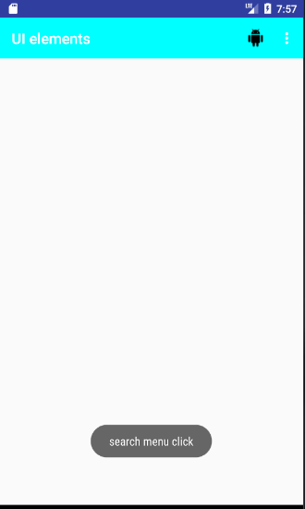 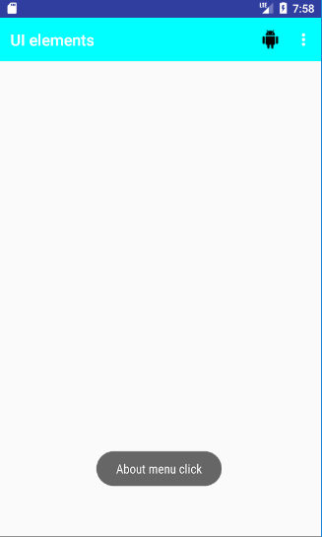

**Practical 5(B): UI Elements: Fragment**

**Input:**

**MainActivity.java**

package com.example.hello.fragtest;  
import android.support.v4.app.FragmentTransaction;  
import android.support.v4.app.FragmentManager;  
import android.support.v7.app.AppCompatActivity;  
import android.os.Bundle;  
public class MainActivity extends AppCompatActivity {  
 public static FragmentManager *fragmentManager*;  
 @Override  
 protected void onCreate(Bundle savedInstanceState) {  
 super.onCreate(savedInstanceState);  
 setContentView(R.layout.*activity_main*);  
 *fragmentManager*=getSupportFragmentManager();  
 if(findViewById(R.id.*fragment_container*)!=null)  
 {  
 if(savedInstanceState!=null)  
 return;  
 FragmentTransaction fragmentTransaction=*fragmentManager*.beginTransaction();  
 First ff=new First();  
 fragmentTransaction.add(R.id.*fragment_container*,ff,null);  
 fragmentTransaction.commit();  
 }  
 }  
}

**First.java**

package com.example.hello.fragtest;  
import android.content.Context;  
import android.net.Uri;  
import android.os.Bundle;  
import android.support.v4.app.Fragment;  
import android.view.*;  
import android.widget.Button;  
public class First extends Fragment {  
 private Button bt;  
 public First() { }  
 @Override  
 public View onCreateView(LayoutInflater inflater, ViewGroup container,  
 Bundle savedInstanceState) {  
 View view=inflater.inflate(R.layout.*fragment_first*,container,false);  
 bt=view.findViewById(R.id.*button*);  
 bt.setOnClickListener(new View.OnClickListener() {  
 @Override  
 public void onClick(View v) {  
MainActivity.*fragmentManager*.beginTransaction().replace(R.id.*fragment_container*,new Second(),null).addToBackStack(null).commit();  
 } });  
 return view;  
 } }

**Second.java**

package com.example.hello.fragtest;  
import android.content.Context;  
import android.net.Uri;  
import android.os.Bundle;  
import android.support.v4.app.Fragment;  
import android.view.*;  
import android.widget.Button;  
public class Second extends Fragment {  
 private Button bt1;  
 public Second() { }  
 @Override  
 public View onCreateView(LayoutInflater inflater, ViewGroup container,  
 Bundle savedInstanceState) {  
 View view=inflater.inflate(R.layout.*fragment_second*,container,false);  
 bt1=view.findViewById(R.id.*button2*);  
 bt1.setOnClickListener(new View.OnClickListener() {  
 @Override  
 public void onClick(View v) {  
 MainActivity.*fragmentManager*.beginTransaction().replace(R.id.*fragment_container*,new Third(),null).addToBackStack(null).commit();  
 } });  
 return view;  
 } }

**Third.java**

**\*\*No Change\*\***

**activity_main.xml**

*<?*xml version="1.0" encoding="utf-8"*?>*<android.support.constraint.ConstraintLayout xmlns:android="http://schemas.android.com/apk/res/android"  
 xmlns:app="http://schemas.android.com/apk/res-auto"  
 xmlns:tools="http://schemas.android.com/tools"  
 android:layout_width="match_parent"  
 android:layout_height="match_parent"  
 tools:context=".MainActivity">  
 <FrameLayout  
 android:id="@+id/fragment_container"  
 android:layout_width="336dp"  
 android:layout_height="463dp"  
 android:layout_marginStart="8dp"  
 android:layout_marginLeft="8dp"  
 android:layout_marginTop="8dp"  
 android:layout_marginBottom="8dp"  
 app:layout_constraintBottom_toBottomOf="parent"  
 app:layout_constraintEnd_toEndOf="parent"  
 app:layout_constraintStart_toStartOf="parent"  
 app:layout_constraintTop_toTopOf="parent">  
 </FrameLayout>  
</android.support.constraint.ConstraintLayout>

**fragment_first.xml**

*<?*xml version="1.0" encoding="utf-8"*?>*<android.support.constraint.ConstraintLayout xmlns:android="http://schemas.android.com/apk/res/android"  
 xmlns:app="http://schemas.android.com/apk/res-auto"  
 xmlns:tools="http://schemas.android.com/tools"  
 android:layout_width="match_parent"  
 android:layout_height="match_parent"  
 tools:context=".First">  
 <TextView  
 android:id="@+id/textView"  
 android:layout_width="wrap_content"  
 android:layout_height="wrap_content"  
 android:layout_marginStart="8dp"  
 android:layout_marginLeft="8dp"  
 android:layout_marginTop="128dp"  
 android:layout_marginEnd="8dp"  
 android:layout_marginRight="8dp"  
 android:text="First Fragment"  
 android:textSize="30sp"  
 app:layout_constraintEnd_toEndOf="parent"  
 app:layout_constraintHorizontal_bias="0.502"  
 app:layout_constraintStart_toStartOf="parent"  
 app:layout_constraintTop_toTopOf="parent" />  
 <Button  
 android:id="@+id/button"  
 android:layout_width="wrap_content"  
 android:layout_height="wrap_content"  
 android:text="Secont Fragment"  
 app:layout_constraintBottom_toBottomOf="parent"  
 app:layout_constraintEnd_toEndOf="parent"  
 app:layout_constraintStart_toStartOf="parent"  
 app:layout_constraintTop_toBottomOf="@+id/textView"  
 app:layout_constraintVertical_bias="0.317" />  
</android.support.constraint.ConstraintLayout>

**fragment_second.xml**

*<?*xml version="1.0" encoding="utf-8"*?>*<android.support.constraint.ConstraintLayout xmlns:android="http://schemas.android.com/apk/res/android"  
 xmlns:app="http://schemas.android.com/apk/res-auto"  
 xmlns:tools="http://schemas.android.com/tools"  
 android:layout_width="match_parent"  
 android:layout_height="match_parent"  
 tools:context=".Second">  
 <TextView  
 android:id="@+id/textView2"  
 android:layout_width="wrap_content"  
 android:layout_height="wrap_content"  
 android:layout_marginStart="8dp"  
 android:layout_marginLeft="8dp"  
 android:layout_marginTop="176dp"  
 android:layout_marginEnd="8dp"  
 android:layout_marginRight="8dp"  
 android:layout_marginBottom="8dp"  
 android:text="Second Fragment"  
 android:textSize="30sp"  
 android:textStyle="bold"  
 app:layout_constraintBottom_toBottomOf="parent"  
 app:layout_constraintEnd_toEndOf="parent"  
 app:layout_constraintStart_toStartOf="parent"  
 app:layout_constraintTop_toTopOf="parent"  
 app:layout_constraintVertical_bias="0.0" />  
 <Button  
 android:id="@+id/button2"  
 android:layout_width="wrap_content"  
 android:layout_height="wrap_content"  
 android:layout_marginStart="8dp"  
 android:layout_marginLeft="8dp"  
 android:layout_marginTop="8dp"  
 android:layout_marginEnd="8dp"  
 android:layout_marginRight="8dp"  
 android:layout_marginBottom="8dp"  
 android:text="Third Fragment"  
 app:layout_constraintBottom_toBottomOf="parent"  
 app:layout_constraintEnd_toEndOf="parent"  
 app:layout_constraintStart_toStartOf="parent"  
 app:layout_constraintTop_toBottomOf="@+id/textView2"  
 app:layout_constraintVertical_bias="0.256" />  
</android.support.constraint.ConstraintLayout>

**fragment_third.xml**

*<?*xml version="1.0" encoding="utf-8"*?>*<android.support.constraint.ConstraintLayout xmlns:android="http://schemas.android.com/apk/res/android"  
 xmlns:app="http://schemas.android.com/apk/res-auto"  
 xmlns:tools="http://schemas.android.com/tools"  
 android:layout_width="match_parent"  
 android:layout_height="match_parent"  
 tools:context=".Third">  
 <TextView  
 android:id="@+id/textView3"  
 android:layout_width="wrap_content"  
 android:layout_height="wrap_content"  
 android:text="Third Fragment"  
 android:textSize="30dp"  
 android:textStyle="normal|bold|italic"  
 app:layout_constraintBottom_toBottomOf="parent"  
 app:layout_constraintEnd_toEndOf="parent"  
 app:layout_constraintStart_toStartOf="parent"  
 app:layout_constraintTop_toTopOf="parent" />  
</android.support.constraint.ConstraintLayout>

**Output:**

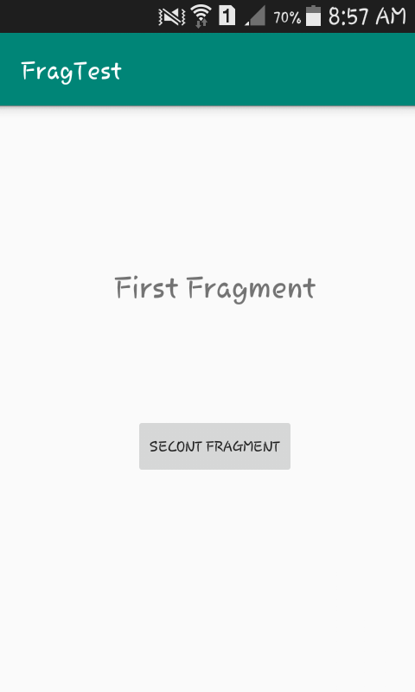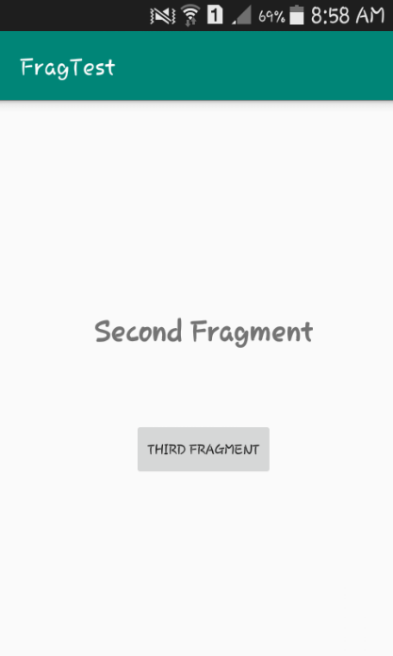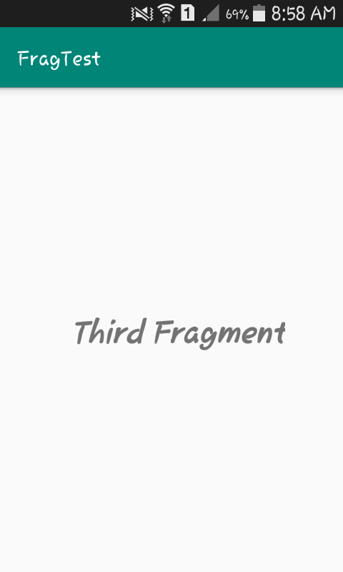

**Practical 5(C): UI Components**

**Input:**

**MainActivity.java**

package com.example.pc.uicomponents;  
import android.support.annotation.IdRes;  
import android.support.v7.app.AppCompatActivity;  
import android.os.Bundle;  
import android.view.Display;  
import android.view.View;  
import android.widget.*;  
import android.widget.Toast;  
import static android.widget.RadioGroup.*;  
public class MainActivity extends AppCompatActivity {  
 Button bsave;  
 ImageButton img;  
 CheckBox cb11,cb12;  
 RadioButton r11,r12;  
 EditText ettext;  
 RadioGroup rgroup;  
 ToggleButton tbutton;  
 @Override  
 protected void onCreate(Bundle savedInstanceState) {  
 super.onCreate(savedInstanceState);  
 setContentView(R.layout.*activity_main*);  
 bsave = (Button) findViewById(R.id.*button*);  
 img = (ImageButton) findViewById(R.id.*imageButton2*);  
 ettext = (EditText) findViewById(R.id.*et*);  
 cb11 = (CheckBox) findViewById(R.id.*cb1*);  
 cb12 = (CheckBox) findViewById(R.id.*cb2*);  
 r11 = (RadioButton) findViewById(R.id.*r1*);  
 r12 = (RadioButton) findViewById(R.id.*r2*);  
 tbutton = (ToggleButton) findViewById(R.id.*tb*);  
 rgroup = (RadioGroup) findViewById(R.id.*rg*);  
 bsave.setOnClickListener(new View.OnClickListener() {  
 @Override  
 public void onClick(View v) {  
 DisplayToast("Saved");  
 }  
 });  
 img.setOnClickListener(new View.OnClickListener() {  
 @Override  
 public void onClick(View v) {  
 DisplayToast("Image Button");  
 }  
 });  
 cb11.setOnClickListener(new View.OnClickListener() {  
 @Override  
 public void onClick(View v) {  
 if(cb11.isChecked())  
 DisplayToast("CheckBox op 1");  
 else  
 DisplayToast("CheckBox unchecked");  
  
 }  
 });  
 cb12.setOnClickListener(new View.OnClickListener() {  
 @Override  
 public void onClick(View v) {  
 if(cb12.isChecked())  
 DisplayToast("CheckBox op 2");  
 else  
 DisplayToast("CheckBox unchecked");  
 }  
 });  
 r11.setOnCheckedChangeListener(new CompoundButton.OnCheckedChangeListener(){  
 @Override  
 public void onCheckedChanged(CompoundButton buttonView, boolean isChecked) {  
 if(r11.isChecked())  
 DisplayToast("Radio Buttuon 1 checked");  
 else  
 DisplayToast("Radio Button 1 unchecked");  
 }  
 });  
 r12.setOnCheckedChangeListener(new CompoundButton.OnCheckedChangeListener(){  
 @Override  
 public void onCheckedChanged(CompoundButton buttonView, boolean isChecked) {  
 if(r12.isChecked())  
 DisplayToast("Radio Button 2 checked");  
 else  
 DisplayToast("Radio Button 2 unchecked");  
 }  
 });  
 tbutton.setOnClickListener(new View.OnClickListener() {  
 @Override  
 public void onClick(View v) {  
 if(tbutton.isChecked())  
 DisplayToast("ToggleButtton is ON");  
 else  
 DisplayToast("Toogle OFF");  
 }  
 });  
 rgroup.setOnCheckedChangeListener(new OnCheckedChangeListener() {  
 @Override  
 public void onCheckedChanged(RadioGroup group, @IdRes int checkedId) {  
  
 }  
 });  
 }  
 public void DisplayToast(String s)  
 {  
 Toast.*makeText*(this,s, Toast.*LENGTH_SHORT*).show();  
 }  
}

**activity_main.xml**

*<?*xml version="1.0" encoding="utf-8"*?>*<LinearLayout xmlns:android="http://schemas.android.com/apk/res/android"  
 xmlns:app="http://schemas.android.com/apk/res-auto"  
 xmlns:tools="http://schemas.android.com/tools"  
 android:layout_width="match_parent"  
 android:layout_height="match_parent"  
 android:orientation="vertical"  
 tools:context="com.example.pc.uicomponents.MainActivity"  
 android:weightSum="1">  
 <Button  
 android:id="@+id/button"  
 android:layout_width="109dp"  
 android:layout_height="wrap_content"  
 android:layout_alignParentTop="true"  
 android:text="Save" />

<ImageButton  
 android:id="@+id/imageButton2"  
 android:layout_width="wrap_content"  
 android:layout_height="wrap_content"  
 app:srcCompat="@mipmap/ic_launcher" />

<EditText  
 android:id="@+id/et"  
 android:hint="Edit Text"  
 android:layout_width="match_parent"  
 android:layout_height="wrap_content" />

<CheckBox  
 android:layout_width="wrap_content"  
 android:layout_height="wrap_content"  
 android:id="@+id/cb1"  
 android:text="Auto Save"/>

<CheckBox  
 android:layout_width="wrap_content"  
 android:layout_height="wrap_content"  
 android:id="@+id/cb2"  
 android:text="Option 2"  
 style="?android:attr/starStyle"/>

<RadioGroup  
 android:id="@+id/rg"  
 android:layout_width="wrap_content"  
 android:layout_height="wrap_content">

<RadioButton  
 android:id="@+id/r1"  
 android:layout_width="wrap_content"  
 android:layout_height="wrap_content"  
 android:text="Option 1"/>

<RadioButton  
 android:id="@+id/r2"  
 android:layout_width="wrap_content"  
 android:layout_height="wrap_content"  
 android:text="Option 2"/>  
 </RadioGroup>

<ToggleButton  
 android:id="@+id/tb"  
 android:layout_width="wrap_content"  
 android:layout_height="wrap_content" />  
</LinearLayout>

**Output:**

